Supervised Visitation and Monitored Child Exchange
The Toby Centers of Connecticut
Serving Great New Haven and New London County, and more!

Southbury | Southbury | Norwich | Norwich
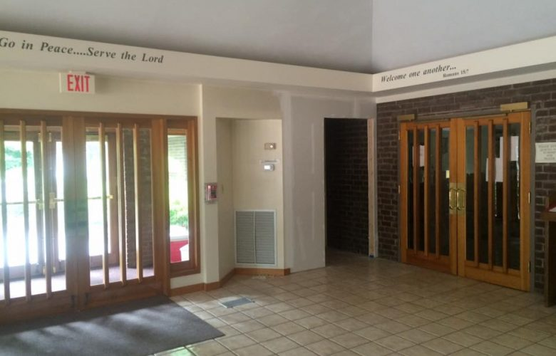 | 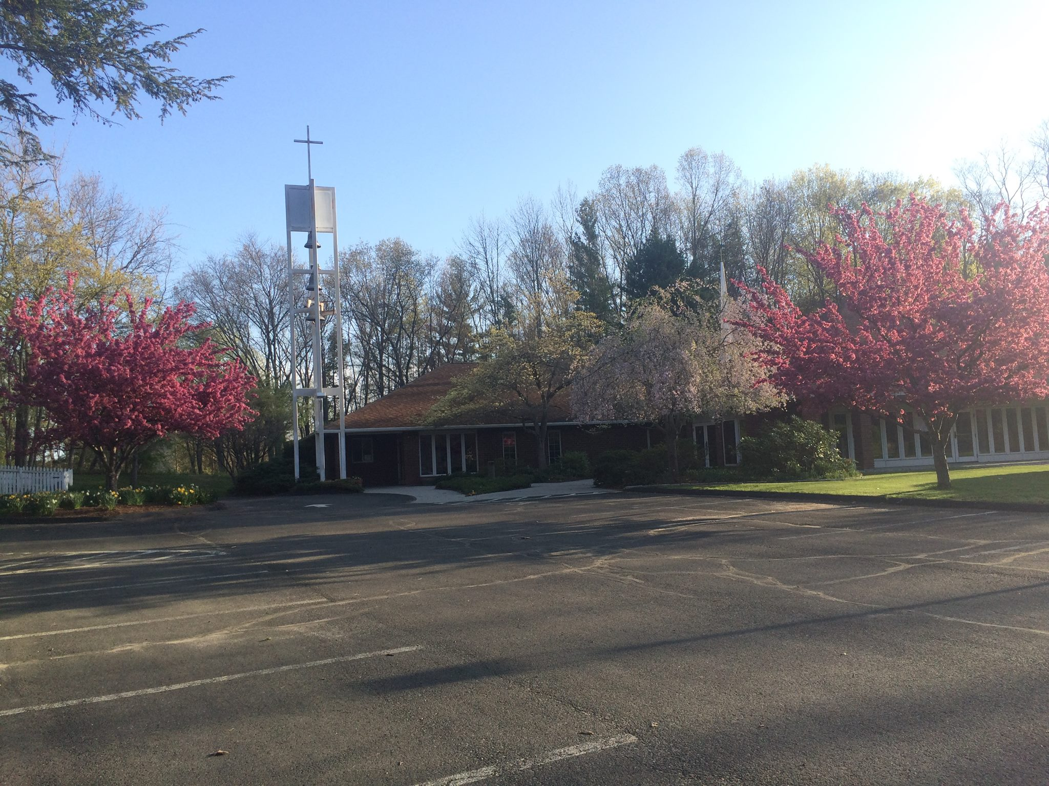 | 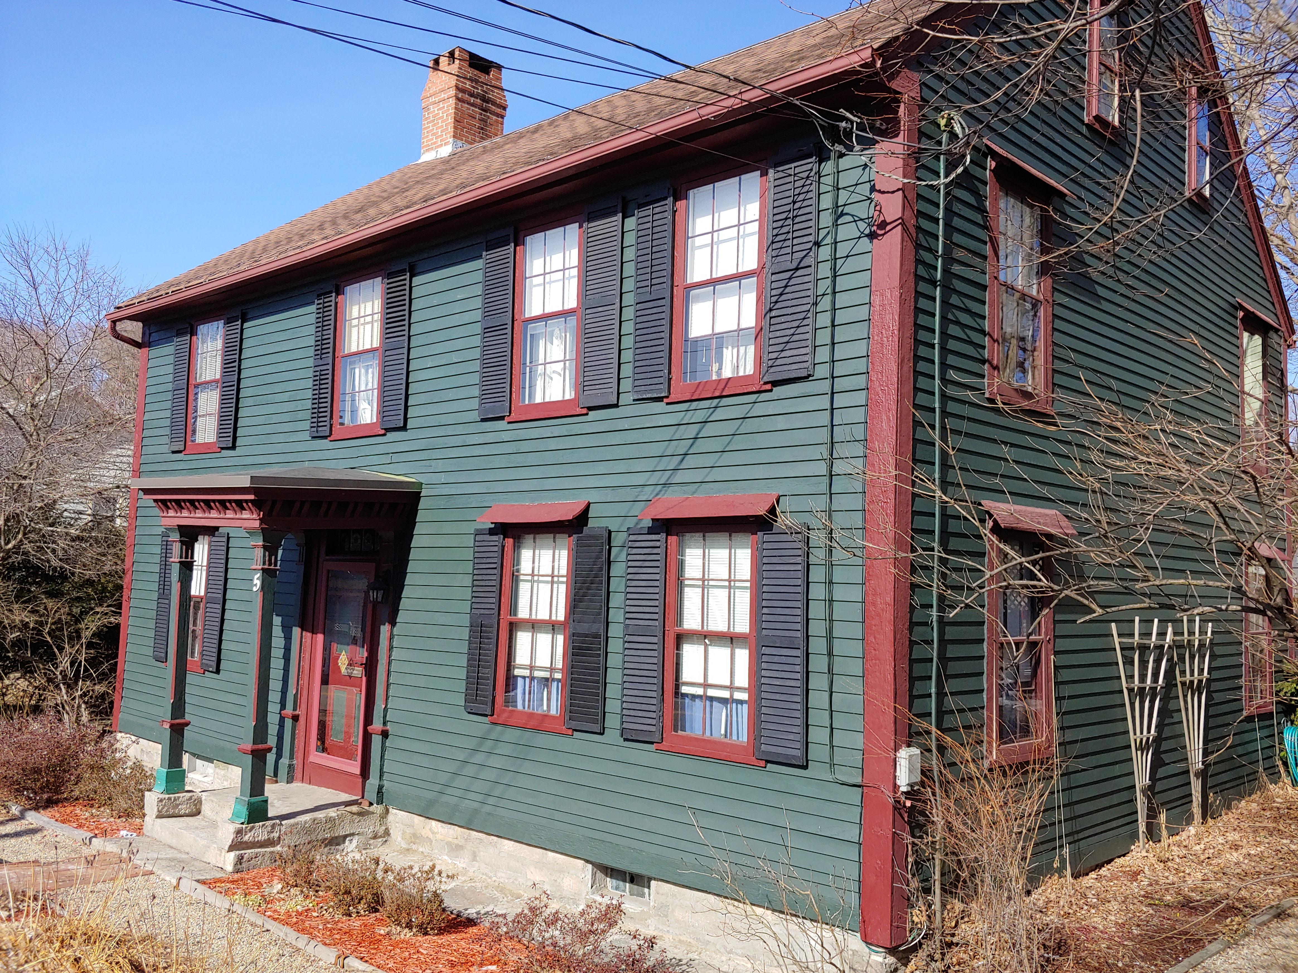 | 
111 Peter Road  Southbury | 111 Peter Road  Southbury | 5 Town Street  Norwich | 78 Washington Street  Norwich

STANDARD AND THERAPEUTIC VISITATION SERVICES AVAILABLE

WHAT: Toby Centers provide supervised visitation, monitored child exchange and therapeutic visitation. Center locations offer parents and children safety, neutrality and comfort for transfer and supervised access/visitation. When appropriate, parents and children will enjoy our recommended community locations, including museums, university campuses and recreation centers. Center Family Monitors are trained observers and document visitations and assure emotional and physical safety. Many are parents, grandparents, students and volunteers bringing skills and knowledge from different fields as education or psychology. Therapeutic staff are licensed clinicians and also registered interns.

WHO: Anyone seeking a neutral, family friendly venue for child transfer and supervised child access/visitation may request visitations with court order or other agreement. Court orders or agreements must specify who may attend the visitations.

WHEN: Visitation services are available anytime during the week and weekend by appointment. Toby Center visitation Weekend schedules at our locations are often on Saturdays and Sundays with sessions typically 9 a.m. – 12 p.m. and 12 p.m. – 2 p.m. Child exchanges can also be scheduled anytime during the week and weekends, with requests often Friday and Sundays between 5 and 6 pm. The Toby Center will accommodate your needs. We do not limit visitation time nor number of sessions.

HOW: Fees for Visitation and Monitored Child Exchange. Visitation fees on sliding scale. Standard Visitation: $45 to $75 per hour. Therapeutic Visitation: $90-120 per hour. Initial Intake fee is required, $90 per parent or guardian. Monitored Child Exchange fee is $49 per one-way exchange per day or evening. Monitored Child Exchange Intake fee is $75 per parent. Prepayment required for all services with credit card or money order. Any admissions for park, museum, etc. is payable by client family. Toby Center will seek to reduce or eliminate these costs with advance notice.

WHY: ALL FAMILY MEMBERS BENEFIT BECAUSE
- Compliance with child support obligations is linked to quality of child access.
- Our family friendly supervised visitation reduces the emotional conflict between parents and children.
- Expedites the transition to a more natural relationship between parents and children.
- Research has found that family friendly child access reduces the conflict level between parents.

ATTORNEYS AND THERAPISTS and CASE MANAGERS
Toby Center Staff are specialists in co-parenting, time share planning, high conflict and mediation. We maintain neutrality, are available to speak at your meetings, and offer child custody consulting.
Visit Us Online at www.thetobycenter.org
Questions? Call 855.862.9239, ext. 1
Email: rose.berkoff@gmail.com

