Funded by
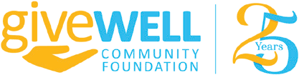

CHILD WELFARE CASE MANAGERS!
Do you have clients who have co-parenting challenges?
Do they have children under 18 years old?

Assign your clients to The Toby Center’s
Co-Parenting Skills Support Program!
Ten weekly 90 minute sessions!
Experienced Therapeutic Facilitator
Funded by The GiveWell Community Foundation

WHO CAN PARTICIPATE?
Have children under 18 years old?
Single and Divorced Moms and
Dads
Frustrated by your current relationship with the other parent?
D Want more time spent nurturing children?
Want to improve children’s school performance?
Want to improve communication between the parents?
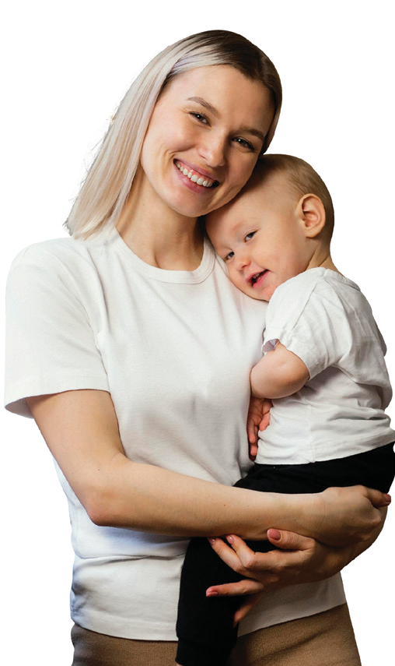
WHY?
Research shows when both parents are involved in their children's lives, the chil- dren have better health, choose better friends and succeed academically!
FREE $50 PUBLIX GIFT CARDS TO ALL PARTICIPANTS!
FREE CERTIFICATES OF COMPLETION!
Freedom to share experiences! Confidential!
-Support other parents with ideas that work for you!
- LEARN NEW WAYS OF COMMUNICATING WITH YOUR CHILD!
- MAKE CHILD RAISING DECISIONS JOINTLY!
- DISCOVER HOW TO COMMUNICATE EFFECTIVELY WITH THE OTHER PARENT!

YOUR CLIENTS CAN ACHIEVE THE GOALS YOU SET FOR THEM! They CAN BE THE PARENT THEY PREFER TO BE!

For further details, application and enrollment:
Call Dr. Mark at 561-265-5400 or email info@thetobycenter.org.
Or Visit www.thetobycenter.org for application!

Provided by
The Toby Center for Family Transitions

To Register, Call 561-265-5400 or email info@thetobycenter.org

LIMITED TO 12 Parents! Custodial and non custodial are both welcome!

Frustrated by your current

