
VIDEO TRAINING MODULES TABLE OF CONTENTS

Video Title and Description | Page #
Welcome and Introduction - A brief welcome and introduction video from the founder of The Toby Center. | 2
Training Module 1 - Role of Toby Center, FL requirements, nature of the work, other topics | 3
Training Module 2 - types of Visitations, discussion of parent’s perspective | 4
Training Module 3 - Supervised visitation process, forms preparation, various policy discussions | 5
Training Module 4 - Round table discussions of Case Studies | 6
Training Module 5 - Hampshire County, MA Zoom Training Meeting | 7
Discussion and Preparation of Forms:
6 Overview and new client process | 8
7 Service Request Form | 9
8 Intake for Supervised Visitations Form | 10
9 Child Intake Form | 11
10 Weekly Activity Report Form | 12
11 Field Report Form | 13
12 Critical Incident and Status Reports Forms | 14
13 Joint Agreement Form | 15

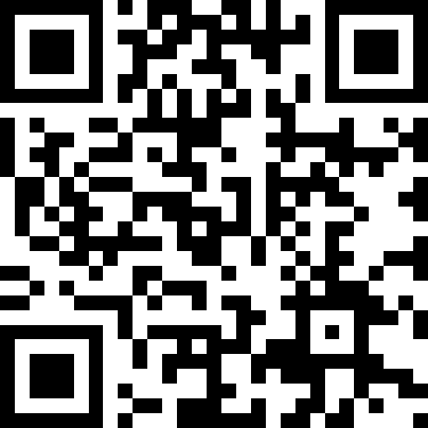

https://youtu.be/IXufL34vyiE?si=rO3iyz0LW5Y3xCC4



https://youtu.be/IXufL34vyiE?si=eiRuza1K9r4Djw8i


https://youtu.be/Prdj4Pyfxq4?si=Cx4wrEoQo8Nplc4Q
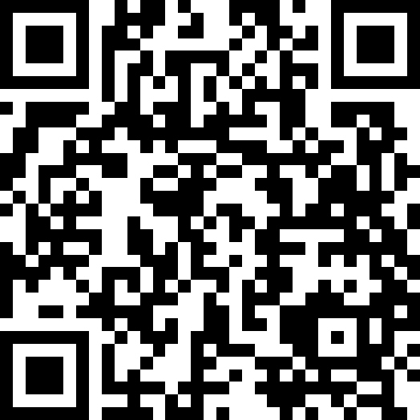

https://youtu.be/dOtTDH3cH9U?si=Uw454OBmGlbcPio2

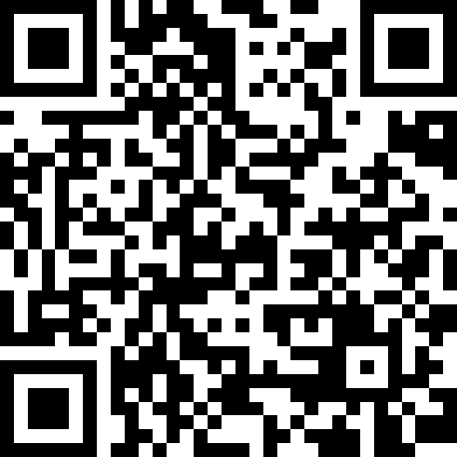
Discussions

https://youtu.be/WLry1rHjxZg?si=meEF6R_EcM0wqI21

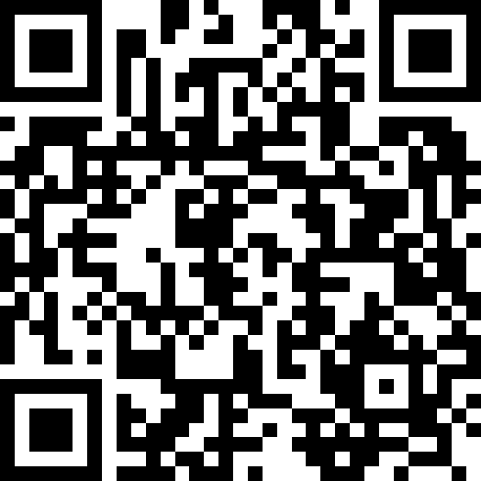
Training Module 5 - Hampshire County, MA Zoom Training Meeting

https://youtu.be/W_B4ld60tBQ?si=kIbTKUO13DhQv4nh

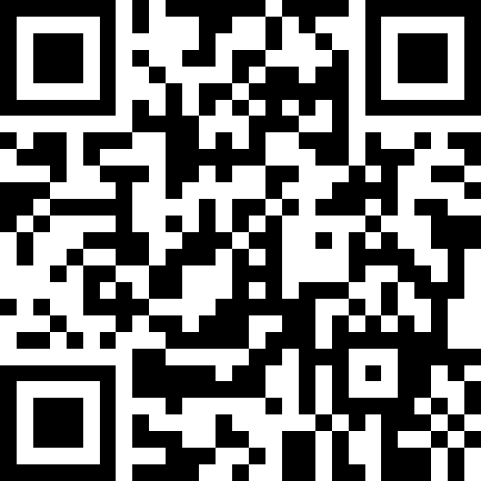

https://youtu.be/XP_q1nFPi3g?si=CxYliXh8EBtmTxz8

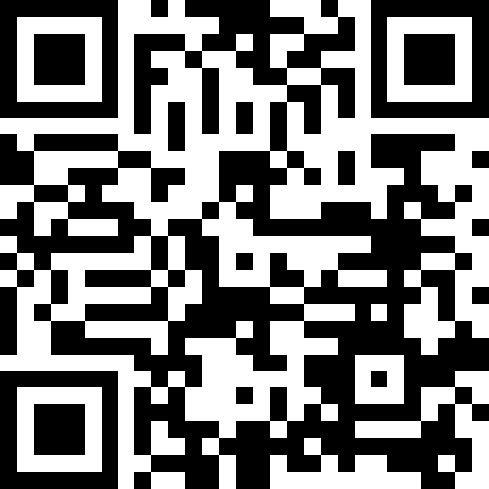

https://youtu.be/vlyAg62YMfA?si=4lBb9yWs9TIj909O

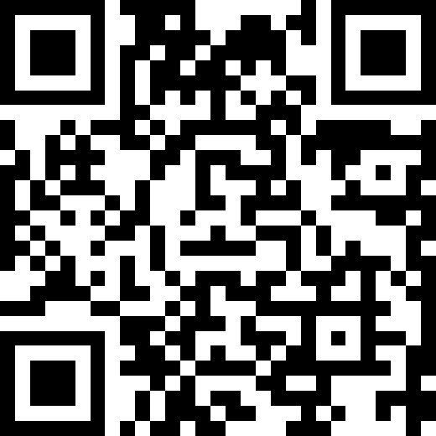

https://youtu.be/QSQ2d7EokT4?si=mhcP96qXr-7pWATu

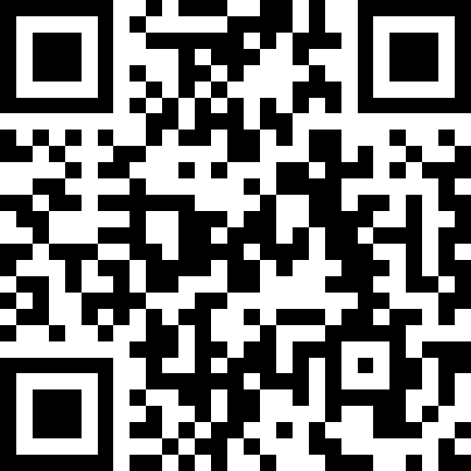

https://youtu.be/AvLKjxvkImY?si=fJPiOTTZmlTSOxXN

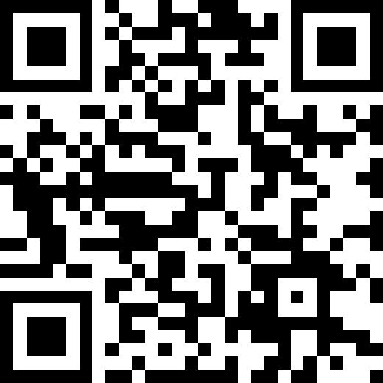
Form

https://youtu.be/pzGJAvA2FUc?si=Tvz6SIGsX3dPJHh8

https://youtu.be/qtdIKUpchvo?si=mSjsr25bbrlMToca

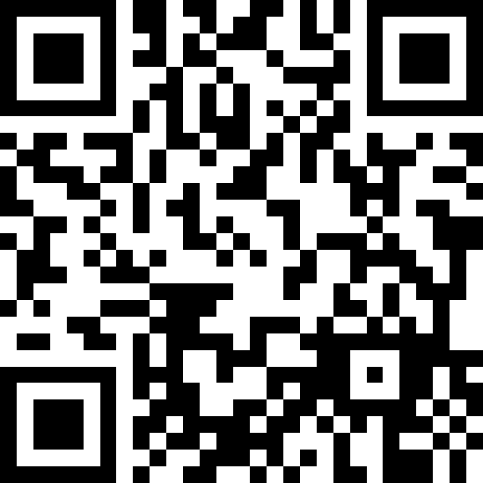

https://youtu.be/7qBB0GPFbLU?si=NQcOwORHuVY2o8tT

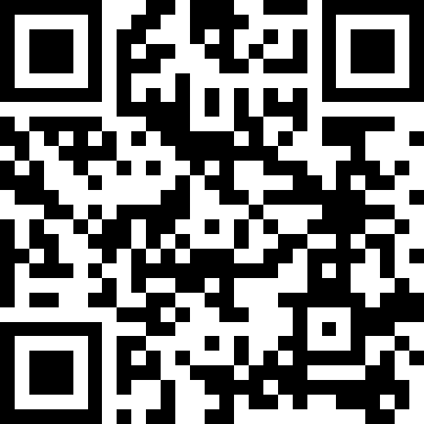

https://youtu.be/H8v6tddzFCU?si=27HpYQDVZbRkjr7a

